Name Period

Lesson 4.1

In Exercises 1–8, decide whether the function is a polynomial function. If so, write it in standard form and state its degree, type, and leading coefficient.

|  |  |
| --- | --- |
|  |  |
|  |  |
|  |  |
|  |  |

**In Exercises 9 and 12, describe the end behavior of the graph of the function.**

1. 
2. 
3. 
4. 

In Exercises 14 and 15, describe the *x*-values for which *f* is increasing, decreasing, positive, and negative.

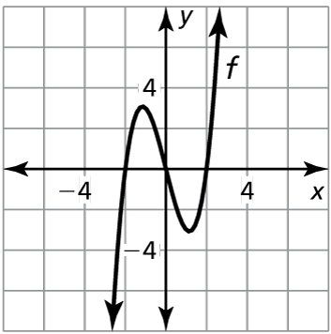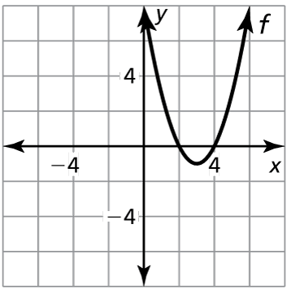13. 14.