Name__________________________________________ Period________ Date__________________________
2.6 Worksheet

Find the value of x and $m∠1$.

1. 2. 3.
1
1

1

4. 5. 6.

1
1

1

Find $m∠1$ using the figure at the right and the given information.

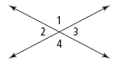
7. $m∠1=5x-9$, $m∠4=2x+90$

8. $m∠1=8x-12$, $m∠1=4x+16$

9. $m∠2=180-3x$, $m∠3=2x$

Complete the proof by filling in the blanks.

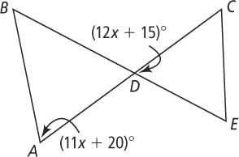
10. Given: $∠A≅∠BDA$
Prove: x = 5

Statements | Reasons
1) ____________________________________ | 1) Given
2) ____________________________________ | 2) Vertical Angles are ≅.
3) ∠A ≅ ∠CDE | 3) ____________________________________
4) ____________________________________ | 4) Definition of Congruence
5) 11x + 20 = 12x + 15 | 5) ____________________________________
6) ____________________________________ | 6) Subtraction Property of Equality
7) ____________________________________ | 7) ____________________________________

Write a two column proof.

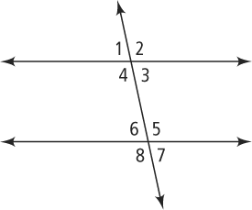
11. Given: $∠5≅∠2$
Prove: $∠8≅∠4$

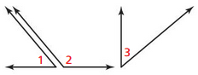
12. Given: $∠1$ and $∠2$ are supplementary
$∠3$ and $∠2$ are supplementary
Prove: $∠1≅∠3$

