Name__________________________________________ Period________ Date__________________________
2.4-2.5 Worksheet

Name the property of equality or congruence that justifies each statement.

1. If $∠A≅∠B$, then $∠B≅∠A$. 2. If $x+3=17$, then $x=14$.

3. $\overline{XY}=\overline{XY}$. 4. If $7x=42$, then $x=6$.

5. If $XY–YZ=XM$, then $XY=XM+YZ$. 6. $2(x+4)=2x+8$.

7. If $m∠A+m∠B=90$ and $m∠A=30$, 8. If $x=y+3$ and $y+3=10$, then $x=10$.
then $30+m∠B=90$.

9. If = 8, then x + 4 = 24. 10. If $AB=CD$, then $AB–EF=CD–EF$.

Complete each proof by filling in the missing statements or reasons.

11. Given: 2(x – 3) = 8
Prove: x = 7

Proof:
Statements Reasons
a. 2(x – 3) = 8 a.

b. 2x – 6 = 8 b.

c. 2x = 14 c.

d. x = 7 d.

12. Given: 3x – 4 = ½ x + 6
Prove: x = 4

Proof:
Statements Reasons
a. 3x – 4 = ½ x + 6 a.

b. 2(3x – 4) = 2(½ x + 6) b.

c. 6x – 8 = x + 12 c.

d. 5x – 8 = 12 d.

e. 5x = 20 e.

f. x = 4 f.

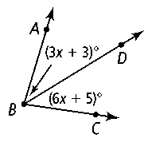
13. Given: $m∠ABC=80°$
Prove: $x=8$

Statements Reasons
a. a.

b. b. Angle Addition Postulate

c. $\left(3x+3\right)+\left(6x+5\right)=80$ c.

d. $9x+8=80$ d.

e. e. Subtraction Property of Equality

f. f.

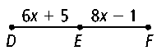
14. Given: E is the midpoint of $\overline{DF}$.
Prove: DE = 23

Statements Reasons

a. E is the midpoint of $\overline{DF}$ a.

b. b. Definition of midpoint

c. $6x+5=8x-1$ c.

d. $5=2x-1$ d.

e. e. Addition Property of Equality

f. f.

g. $DE=6x+5$ g. Given

h. $DE=6\left(3\right)+5$ h.

i. i.
Write a two-column proof.

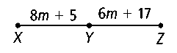
15. Given: $XY=YZ$
Proof: $m=6$

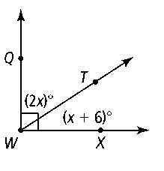
16. Given: $∠QWT and ∠TWX are complementary$
Prove: $x=28$

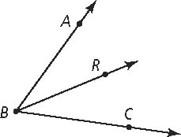
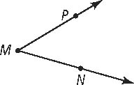
17. Given: m∠PMN = m∠RBC
Prove: m∠ABR + m∠PMN = m∠ABC

