In geometry, a rule that is accepted without proof is called an axiom or a _____________.

Ruler Postulate

Segment Addition Postulate

Line segments that have the same length are called ___________ segments. Their lengths or the distances between their respective points are ______________ but the segments are _______________.  AB = CD is read  .  $\overline{AB}≅\overline{CD}$ is read  .  Example 1 - Find DE to the nearest millimeter.  D  E | Example 2 – Find the distance between Mary Lake and Beach Lake.  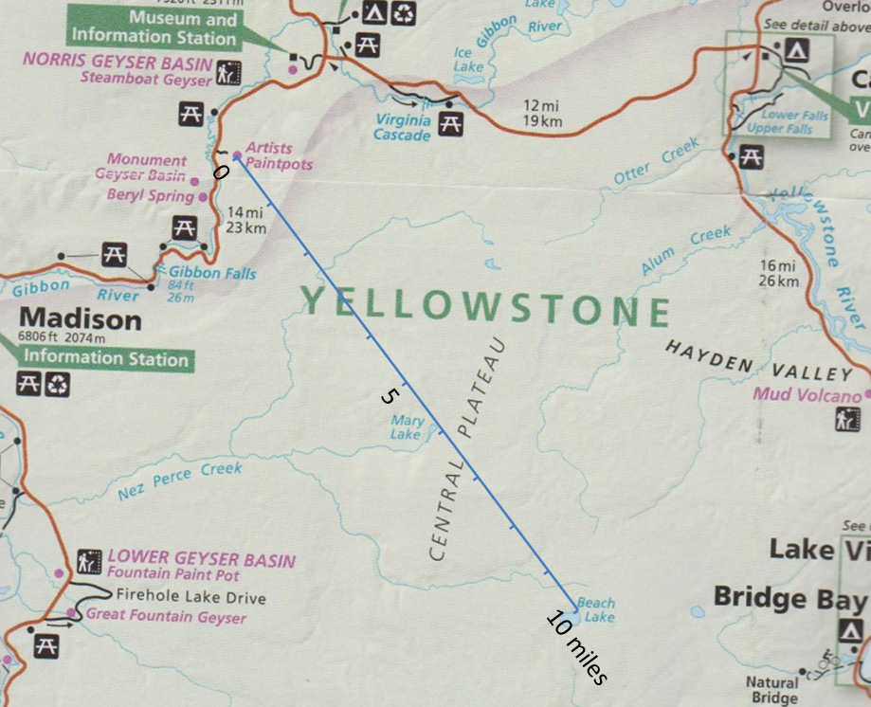
When three points are collinear, you can say that point is _______________ the other two. | Example 4 – Find XZ.  26  7  Y  X  Z  Example 5 – Find EF.  41  D  F  E  25

Example 3  Plot the points P(-4, 2), Q(3, 3), R(-1, 4), and  S(-1, -2) in a coordinate plane. Then determine whether$\overline{PQ}≅\overline{RS}$.  Example 6 - Determine the distance between Springfield, MO and St. Louis, MO.  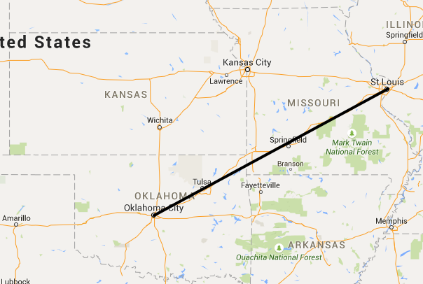  286.2  499.2 | Example 3  Plot the points P(-4, 2), Q(3, 3), R(-1, 4), and  S(-1, -2) in a coordinate plane. Then determine whether$\overline{PQ}≅\overline{RS}$.  Example 6 - Determine the distance between Springfield, MO and St. Louis, MO.  286.2  499.2

