Equation/Function | Table of Values | Domain, Range, Int. | Graph
 | x y | Domain:  Range: | 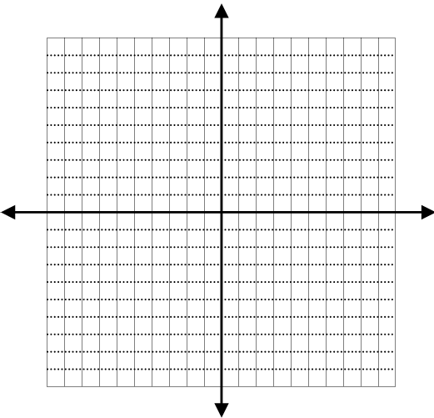
y-intercept:

x-intercept:

 | x y | Domain:  Range:  y-intercept:  x-intercept:
 | x y | Domain:  Range:  y-intercept:  x-intercept:
Equation/Function | Table of Values | Domain, Range, Int. | Graph
 | x y | Domain:  Range:
y-intercept:

x-intercept:

 | x y | Domain:  Range:  y-intercept:  x-intercept:
 | x y | Domain:  Range:  y-intercept:  x-intercept:

