Example:  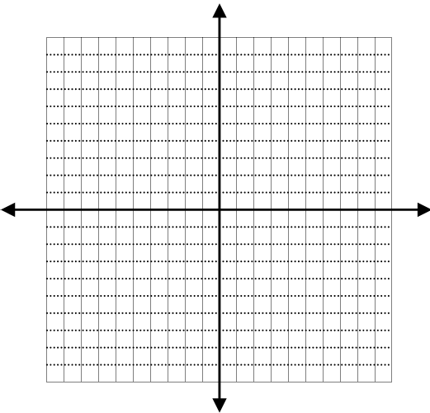 | The graph of the function is | The graph of the function is | Example:
Example: | The graph of the function is | The graph of the function is | Example:
Example: | The graph of the function is | The graph of the function is | Example:
Examples: | The graph of the function is | The graph of the function is | Examples:

Example: | The graph of the function is | The graph of the function is | Example:
Example: | The graph of the function is | The graph of the function is | Example:
Example: | The graph of the function is | The graph of the function is | Example:
Examples: | The graph of the function is | The graph of the function is | Examples:

