How Are Magazines Faring?
There is no doubt that the Internet has changed our lives. Information is instantly available; it has changed our patterns, what we buy, and how we communicate. Print media is one industry that is attempting to reinvent itself to survive in the Internet age. Use your investigative skills and number crunching abilities to answer the questions below.
MPA – The Association of Magazine Media releases Ad Dollars and Ad Pages for various magazines each year. Use the links below and a spreadsheet to gather these numbers for your magazine of choice for the years listed below. Do not choose Sports Illustrated because it is used as an example.

January - December 2003 vs 2002
January – December 2004 vs 2003
January – December 2005 vs 2004
January – December 2006 vs 2005
January – December 2007 vs 2006
January – December 2008 vs 2007
January – December 2009 vs 2008
January – December 2010 vs 2009
January – December 2011 vs 2010
January – December 2012 vs 2011
January – December 2013 vs 2012

Depending on how you gather your data, it may look something like this.
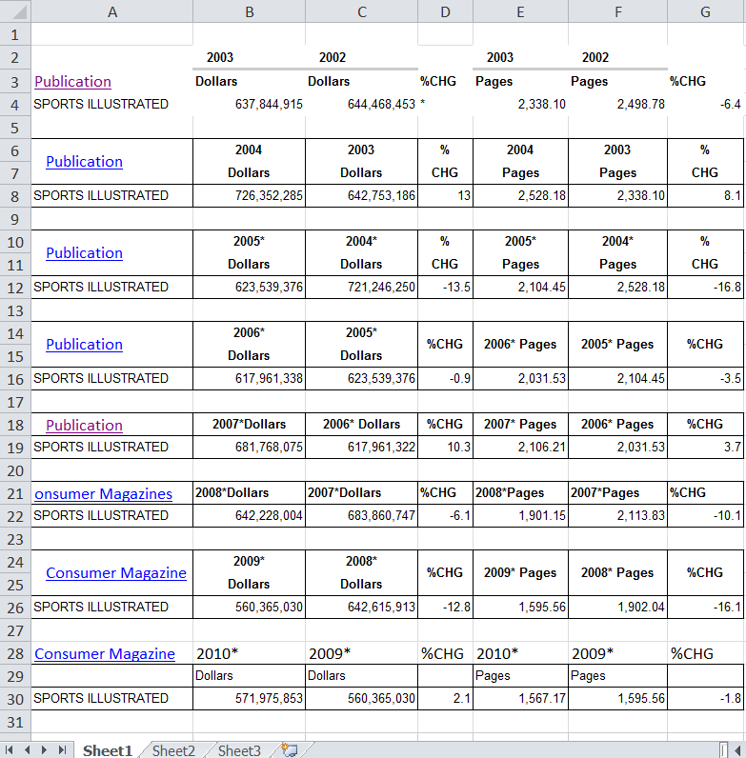

Is it equitable to compare ad revenue from 2002 with revenue from 2013 without any adjustments?
What adjustment should be made? What year should you compare each year to?

If a year has two different numbers listed, which will you use? Why?

Use a US inflation calculator to adjust the dollar amounts for inflation. When you are finished you may have a table that looks like this.
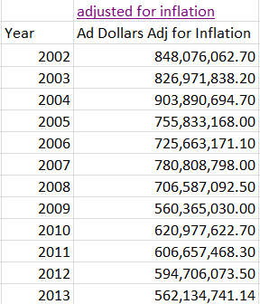

Copy the data in your table to Desmos.com. How will you adjust your x- and y- axis to display the data correctly?

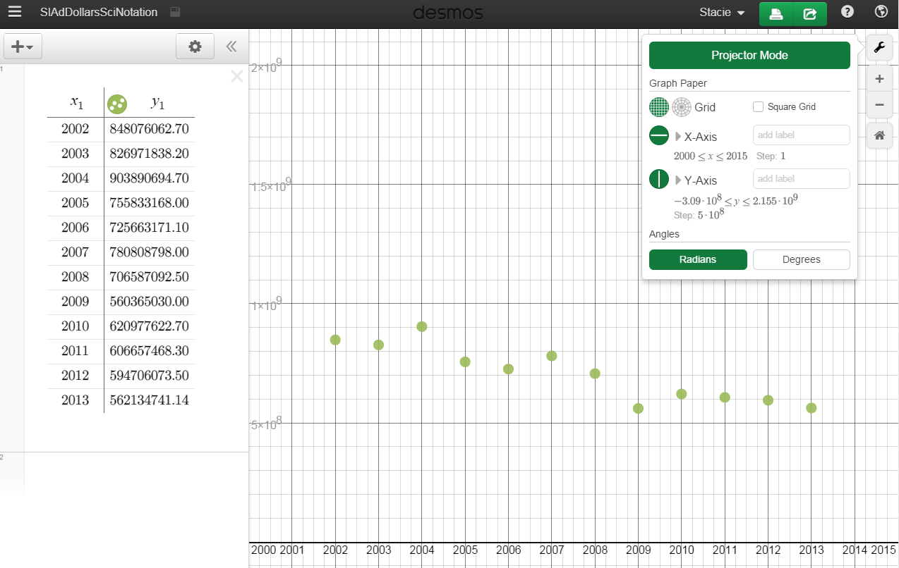

Can you adjust the data in some way to make it more human friendly?

Is your magazines sales growing, remaining flat, or falling?

Do the data points trend to a line, an exponential growth or decay, or some other type of curve?

If your data appears linear, use Desmos to find the line of best fit.

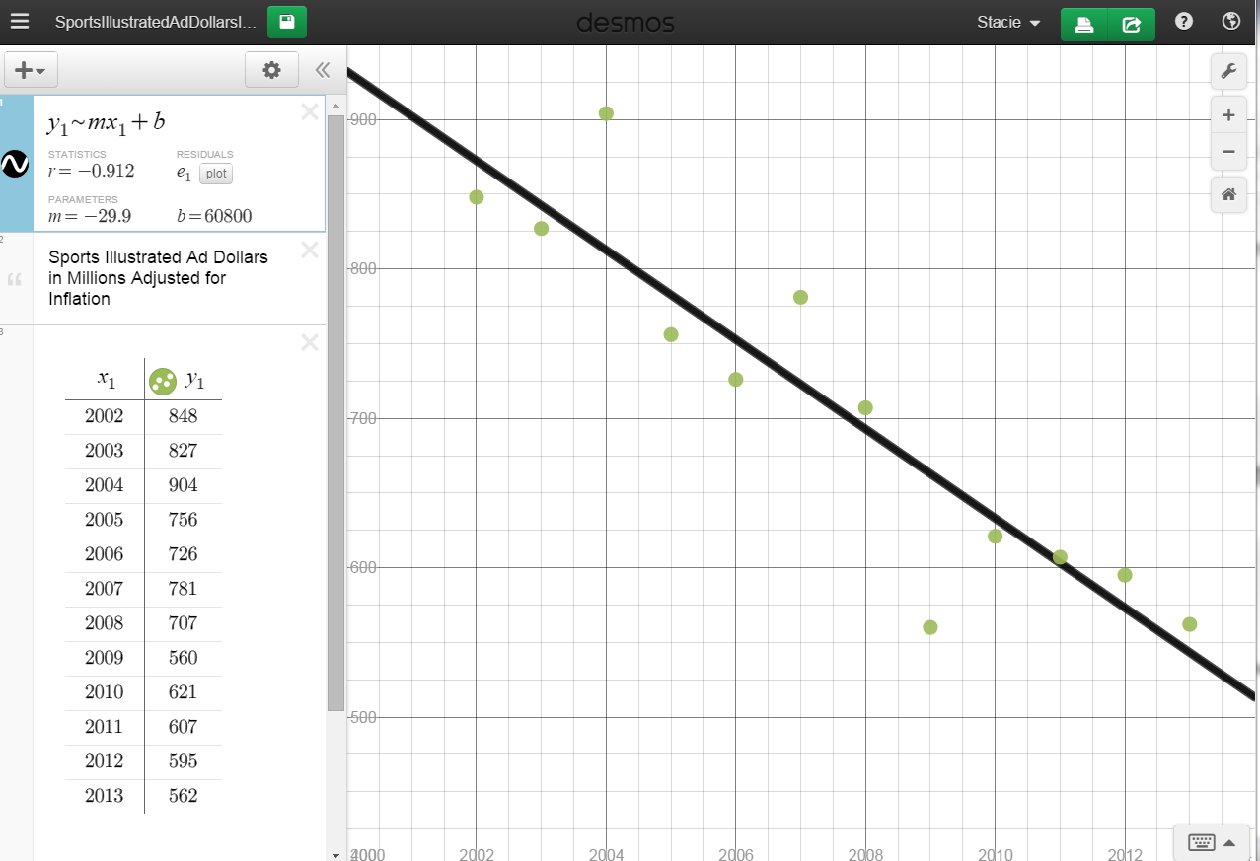

What does your “m” represent?

What does “b” represent?

What would your magazine’s x-intercept represent?

If you adjust the Ad Pages values for inflation and plot the data will it have a similar appearance?

If you find the line of best fit will it have the same “m” and the same “b”?

Why or why not?

Will it have the same x-intercept?

This source looked at advertising revenue. What other sources of data could be used to gauge the health of the magazine industry?

What other industries have been disrupted by the Internet?

Which industries do you believe are enjoying growth due to the Internet?

