**Graphing Linear Equations**  Name ________________________

# http://education.ti.com/images/product/tech/83p/83Pbig.JPGWith the TI-83+

1.

3.

5.

7.

This activity will help you become familiar with the graphing calculator. In it, you will learn to graph equations of lines, change the window, locate intercepts, and work with the table function of the calculator.

1. Start by turning the calculator on.
2. If you don’t have a blank screen, press the *2nd* button, then *QUIT (shift of MODE).*
3. Press the *Y=* button.
4. If there is an equation stored in Y­1 , press the *CLEAR* button. Repeat for Y2 and any other values that have an equation stored.
5. With your cursor in the Y1 line, type 2 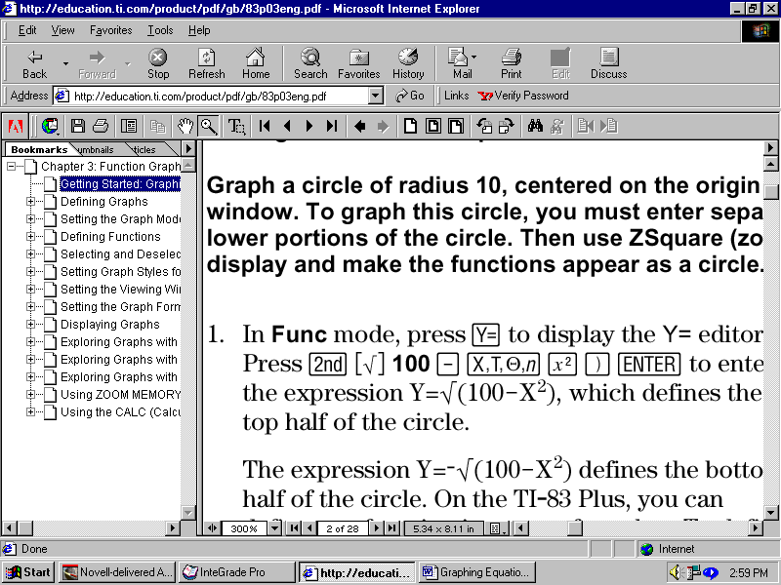+3 then *Enter.*  You now have the equation y = 2x + 3 entered into the computer.
6. Press the *ZOOM* key. Choose option 6 for *ZStandard*. This gives you a coordinate plane with –10 to 10 as its x and y values.
7. Press the *2nd* button, then *TABLE (shift of GRAPH*) to see a table of values for your equation.
8. Draw the table with 6 values for x and y below.

|  |  |
| --- | --- |
| **x** | **y** |
|  |  |
|  |  |
|  |  |
|  |  |
|  |  |
|  |  |

1. Press the *GRAPH* button to see the line again and sketch what you see on the calculator on the coordinate plane at the right.
2. Repeat the process with the equation 4x + y = -5.

|  |  |
| --- | --- |
| **x** | **y** |
|  |  |
|  |  |
|  |  |
|  |  |
|  |  |
|  |  |

1. Repeat the process with the equation .
2. Did you get a line? ______________ What do you think happened to it? ______________________  
   _________________________________________________________________________________

|  |  |
| --- | --- |
| WINDOW | |
| Xmin = | -40 |
| Xmax = | 10 |
| Xscl = | 5 |
| Ymin= | -10 |
| Ymax = | 40 |
| Yscl = | 5 |

1. Press the *WINDOW* key. Change the values to reflect those in the table at the right.
2. Press the *GRAPH* button. Sketch the equation below. Be sure to change your scale on your graph paper.
3. Determine which values are needed to display the x- and y- intercepts of the graph of y = 5x + 60.

|  |  |
| --- | --- |
| WINDOW | |
| Xmin = |  |
| Xmax = |  |
| Xscl = |  |
| Ymin= |  |
| Ymax = |  |
| Yscl = |  |

***Solve  if the domain is (-6, -3, 0, 3, 6, 9).***

1. Type the equation y=(2x – 6)/3 in *Y1*. Press *2nd* then *TBLSET (shift of WINDOW).* Change *TblStart =* to -6 and *ΔTBl =* to 3. Press *2nd* then *TABLE* to view the values for x and y. Record your table below.

|  |  |  |  |  |  |  |
| --- | --- | --- | --- | --- | --- | --- |
| x |  |  |  |  |  |  |
| y |  |  |  |  |  |  |

1. Sketch the graph to the right.
2. Why did 2x - 6 have to be in parenthesis in number 16? _____________________________________

____________________________________________________________________________________

19. Why did we choose *ΔTBl =* to be equal to 3? ___________________________________________  
____________________________________________________________________________________